Market Busket Analysis Using Apriori Algorithm Lab Work

Prosanto Mojumdar, Student ID: 200226

Utsa Debnath, Student ID: 200242

Khulna University, Khulna

**Introduction:**

This report provides an overview and analysis of the **Zomato Restaurant Dataset**, which can be utilized to build recommendation system, analyze data trend, predict food price and much more.  The dataset contains a comprehensive list of restaurants from different parts of the world, with key attributes such as restaurant name, their link , average rating, cuisine type, and pricing.

**Dataset Overview:**

The dataset consists of restaurants in Hyderabad, including their names, ratings, types of cuisines offered, and the price for one person. The focus of this analysis is on the "cuisine" column, where each restaurant offers a combination of various cuisines. These combinations are treated as transactions for the Apriori algorithm to identify frequent cuisine itemsets.

**Dataset Source :**<https://www.kaggle.com/datasets/deewakarchakraborty/zomato-restaurant-dataset>

**Dataset Snapshot:**

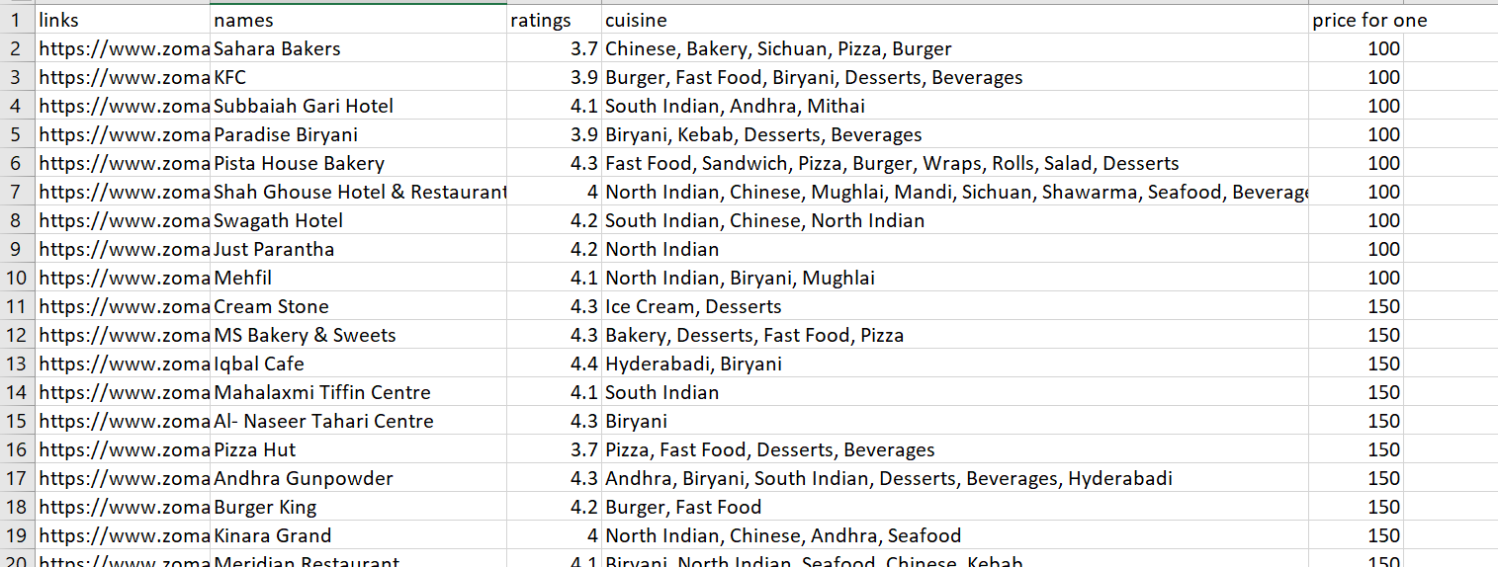

**No of samples:**

There are **5 columns** in the dataset. **657 records** of Zomato restaurants. The cuisines have been stringed together for each restaurant. It is difficult to provide insights with the format in the dataset. There are no duplicate values to be found

**Number of categories:**

There are 5 numbers of category.

* **links:** Contains links to the order page of the restaurants.
* **names:** Name of the restaurants.
* **ratings:** Average of the rating given by the all the customers.
* **cuisine:** Cuisine served by the restaurants.
* **price for one:** Cost of the food for one person in INR.

**Unique items:**

* There are 636 unique restaurant and there are 58 unique cuisine are sold in restaurants. They are Fast Food, Sandwich, Pizza, Burger, Wraps, Rolls, Salad, Desserts, Chinese etc.

**Dataset size:** 84 kilobyte

**Result and Findings:**

**Optimal Support**

The optimal minimum support found for the dataset was **3%**, which maximized the number of frequent cuisine combinations (75 frequent itemsets). This threshold ensures that itemsets appearing in at least 3% of the restaurant offerings are considered frequent, providing a good balance between coverage and significance.

**Key Frequent Itemsets**

**Frequent 1-itemsets (Individual Cuisines)**

Chinese (131 occurrences) and Desserts (189 occurrences) are among the most offered cuisines across Hyderabad restaurants. Fast Food (159 occurrences), Beverages (182 occurrences), and North Indian (153 occurrences) are also highly popular, representing staple food types in this region.

**Frequent 2-itemsets (Cuisine Pairs)**

Chinese & North Indian (90 occurrences): This combination is popular, reflecting the blend of local and international cuisines. Burger & Fast Food (36 occurrences) and Beverages & Fast Food (78 occurrences): These pairings are common, likely reflecting popular quick-serve or casual dining preferences. Desserts & Fast Food (58 occurrences) and Beverages & Desserts (74 occurrences): This suggests a high demand for dessert and drink combinations in restaurant menus.

**Frequent 3-itemsets (Cuisine Triples)**

Beverages, Desserts, & Fast Food (32 occurrences): This combination is one of the most frequent across restaurants, indicating a strong market for eateries offering full meal packages. Chinese, North Indian, & South Indian (26 occurrences): Combining different Indian cuisines with Chinese is a prevalent offering in Hyderabad restaurants. Biryani, Chinese, & North Indian (29 occurrences): Biryani is a popular local dish, and it's often combined with other cuisines to cater to a variety of tastes.

**Findings**

Chinese cuisine appears to be the most frequent, either alone or in combination with other cuisines, highlighting its popularity across restaurants in Hyderabad. Fast food and beverages combinations are highly frequent, indicating the demand for quick and casual dining options in the market. Desserts paired with drinks or fast food are a popular combination, likely reflecting consumer preferences for light meals or snacks with beverages. Fusion offerings, such as North Indian paired with Chinese or South Indian dishes, are common, indicating that restaurants aim to cater to diverse tastes by blending local and international cuisines.

**Business Implications**

For restaurant owners: Offering combinations of Chinese, fast food, desserts, and beverages is likely to attract a large portion of the market. Additionally, introducing fusion dishes that blend Indian and international cuisines could further broaden customer appeal.

For new entrants: Focusing on popular combinations, such as fast food with beverages and dessert options, could help establish a solid market presence.

For customers: The analysis highlights the strong diversity of available cuisines, suggesting that restaurants in Hyderabad tend to cater to a wide array of preferences.

**Conclusion:**

The market basket analysis of Hyderabad restaurants reveals key insights into the most popular cuisine combinations offered across the city. The study identifies that Chinese, Fast Food, and Desserts are the leading individual cuisines, often combined with Beverages. The prevalence of fusion combinations, particularly Chinese with Indian cuisines (such as North Indian and South Indian), showcases the adaptability of restaurant offerings to local tastes while maintaining global appeal.